* CMC Curve : Cumulative Match Characteristic Curve
  + Closed set - Gallery contains the correct identity of the probe(guaranteed)
    - But will it actually find it?
  + Each probe biometric sample is compared against all gallery samples
  + The resulting scores are **sorted** and **ranked.**
  + Determine the rank at which **true match** occurs.
  + True Positive Identification Rate (**TPIR)**: probability of observing the **correct identity** within the **top K ranks**.
  + CMC Curve: Plots TPIR against ranks
  + CMC Curve: Ranked-based metric
  + 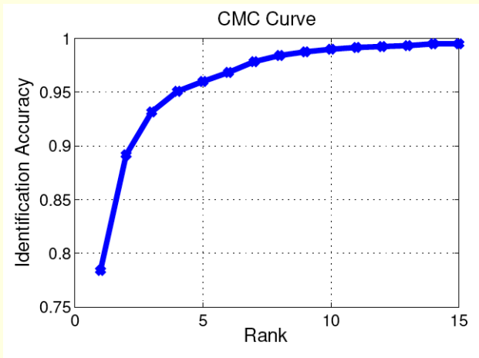
  + Open-set: Gallery may or may not contain the correct identity of the probe.
  + Each probe biometric sample is compared against all gallery samples.
  + A set of all gallery samples whose scores exceed a threshold is returned.
  + True Positive Identification Rate (TPIR): Probability of observing the correct identity in the returned set.
  + False Positive Identification Rate (FPIR): Probability that the correct identity does not occur in the returned set.
* Biometric Traits
  + Uniqueness (Is it distinctive across individuals?)
  + • Permanence (Does it change over time?)
  + • Universality (Does every subject have it?)
  + • Collectability (Can it be measured quantitatively?)
  + • Acceptability (Is it acceptable to the subjects?)
  + • Performance (Does it meet error rate, throughput, etc.?)
  + • Vulnerability (Can it be easily spoofed or obfuscated?)
  + • Integration (Can it be embedded in the application?)
* Invariant Representation - underlying object might change. But the extracted features do not change.
  + Example - finger might change. But munitae points are the same.